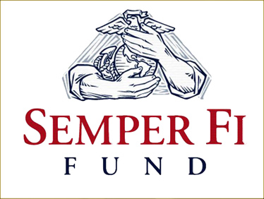
[Type a quote from the document or the summary of an interesting point. You can position the text box anywhere in the document. Use the Text Box Tools tab to change the formatting of the pull quote text box.]
Glenn Bowers Memorial
Golf Tournament
SPONSOR SHEET
Randy Shoup, 18 Red Oak Drive , Danville, PA 17821
Phone: 570-204-1880
E-mail: gbmgt214@gmail.com

MUST BE RECEIVED WITH PAYMENT BY JULY 1, 2012 IN ORDER TO RECEIVE RECOGNITION IN EVENT PROGRAM AND BANNER.
Company Name and phone number:__________________________________________________________
Address:___________________________________________________________________________________________________________________________________________________________________________________
Please check which level you would like to participate at.
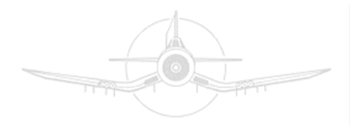Corsair Sponsorship – $5,000 - This is the premier sponsorship for this event. Glenn Bowers flew the Chance Vought F4U Corsair aircraft in combat in the Pacific theater. A sponsor at this level will receive two foursomes, individual banner at the event, mention in the event program and mention on the event website; which can include your company logo. Verbal recognition of your company’s generosity will be provided at the awards dinner. Make sure to check the sponsor box on the entry form and fill out.
Wildcat Sponsorship - $2,500 – Wildcat sponsors will receive golf for four, recognition on a banner at the event, mention in the event program and on the event website; which can include your company logo. Verbal recognition of your company’s generosity will be provided at the awards dinner. Make sure to check the sponsor box on the entry form and fill out.
Thunderbolt Sponsorship- $1,000 – Thunderbolt sponsors will receive golf for four, recognition on a banner at the event, mention in the event program and on the sponsor page of the event website which can include company logo. Verbal recognition of your company’s generosity will be provided at the awards dinner. Make sure to check the sponsor box on the entry form and fill out.
Hellcat Sponsorship- $500 – Hellcat sponsors receive recognition on a banner at the event, mention on the sponsors page of the event website and the event program. Verbal recognition will be provided at the awards dinner.
Mustang Sponsorship- $250 – Mustang sponsors receive recognition on a banner at the event and in the event program. Verbal recognition will be provided at the awards dinner.
Warhawk Sponsorship- $100 – Warhawk sponsors are the hole sponsors for this event. Warhawk sponsors will receive tee box signage for the hole(s) they have sponsored and mention in the event program
Avenger Sponsorship - $50 – An Avenger sponsorship is a great way for small businesses and individuals to show support for injured Marines and their families. The sponsor’s name will be prominently displayed on a participating golf cart and in the event program.

Please make checks payable to: Glenn Bowers Memorial Golf Tournament
Mail To: Randy Shoup
18 Red Oak Drive
Danville, PA 17821
(570) 204-1880

